**KEERTHANAN G B I**

**B TECH IT - B**

**DAY - 7**

1)package DAY7;

import org.openqa.selenium.WebDriver;

import org.openqa.selenium.chrome.ChromeDriver;

import org.openqa.selenium.chrome.ChromeOptions;

import org.testng.Assert;

import org.testng.annotations.Test;

import io.github.bonigarcia.wdm.WebDriverManager;

public class NewTest_1 {

@Test

public void f() {

WebDriverManager.chromedriver().setup();

WebDriver driver;

ChromeOptions co = new ChromeOptions();

co.addArguments("--remote-allow-origins=*");

driver=new ChromeDriver(co);

driver.navigate().to("https://demo.wpeverest.com/user-registration/guest-registration-form/");

String url=driver.getTitle();

Assert.assertEquals(url, "Guest Registration Form – User Registration");

}

}

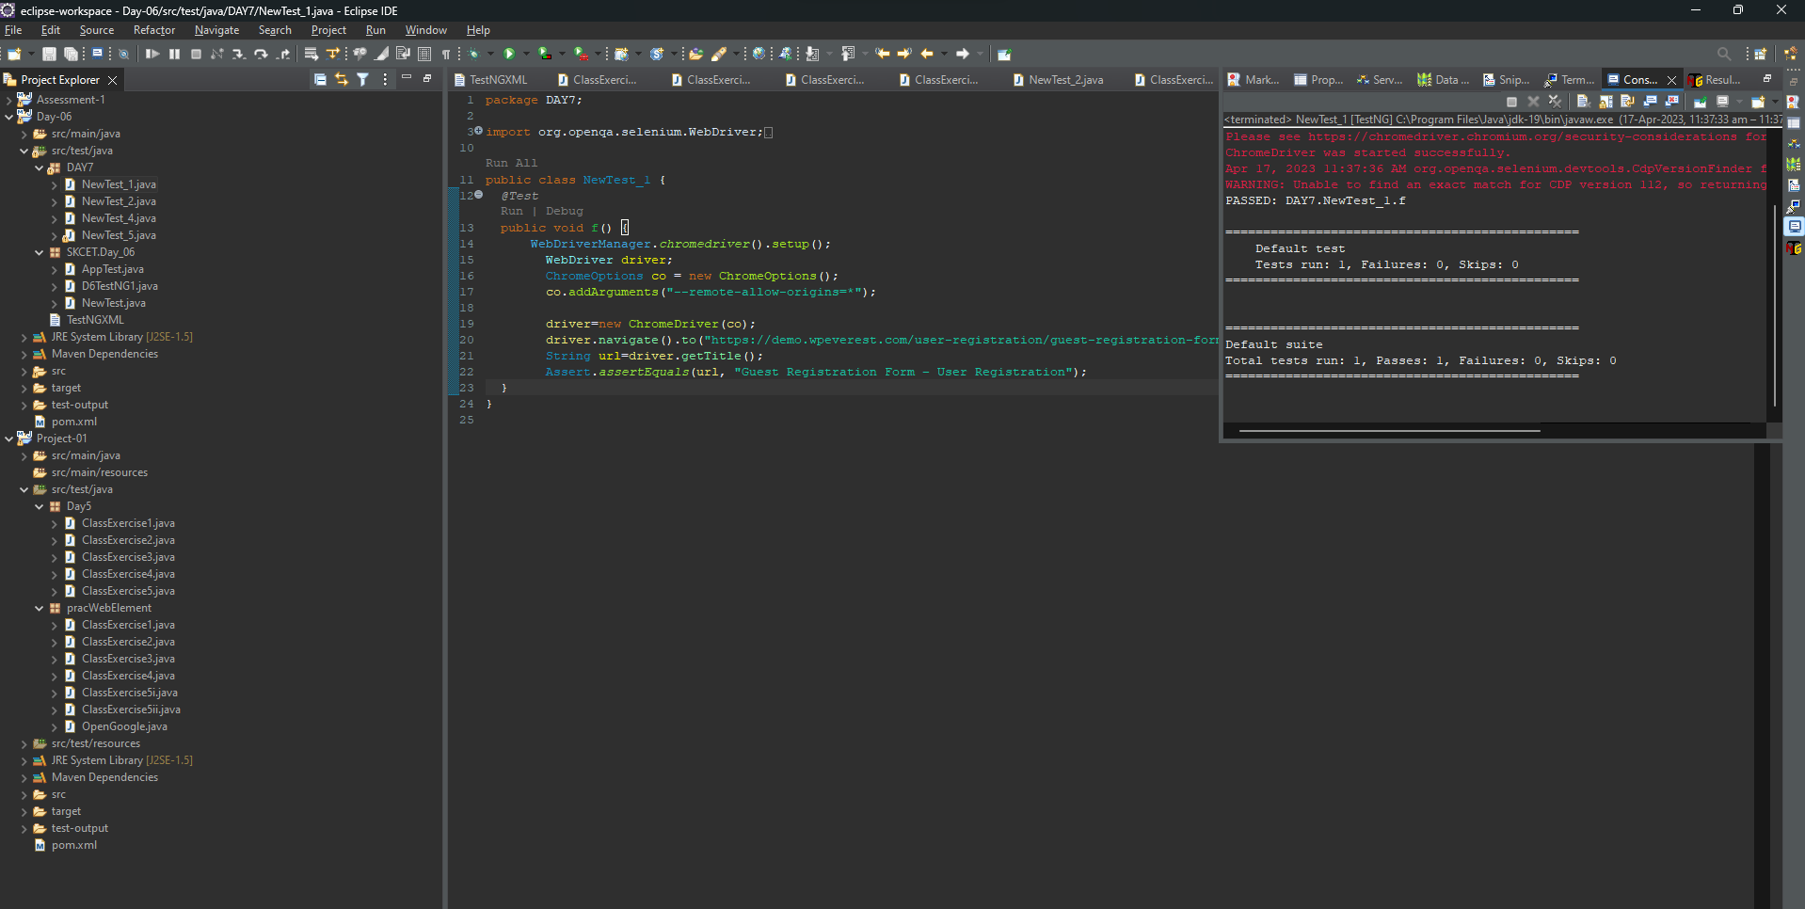**2)**package DAY7;

**OUTPUT:**

import org.testng.Assert;

import org.testng.annotations.Test;

public class NewTest_2{

public class Calculator { int a=10,b=2, c=0; @Test(priority=4) public void add() {

c=a+b;

System.out.println("Addition : "+c); Assert.assertEquals(12,c);

}

@Test(priority=3)

public void sub() {

c=(a-b);

System.out.println("Subtraction : "+c); Assert.assertEquals(8,c);

}

@Test(priority=2)

public void multiply() {

c=(a*b);

System.out.println("Multiplication :"+c);Assert.assertEquals(20,c);

}

@Test(priority=1)

public void divide() {

c=(a/b);

System.out.println("Division :"+c);Assert.assertEquals(5,c);

}

}

}

**OUTPUT:**

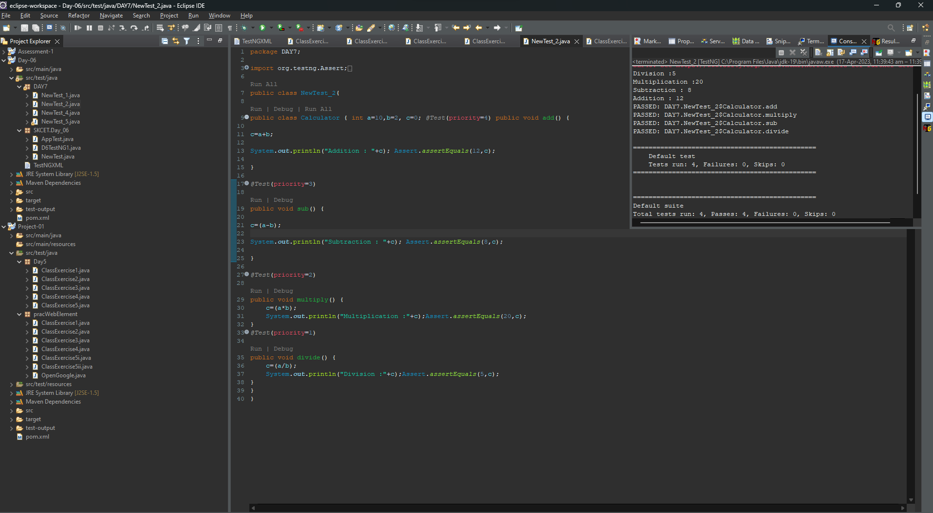

**3)**package DAY7;

import org.openqa.selenium.By;

import org.openqa.selenium.WebDriver;

import org.openqa.selenium.chrome.ChromeDriver;

import org.testng.annotations.AfterMethod;

import org.testng.annotations.BeforeMethod;

import org.testng.annotations.Test;

import org.openqa.selenium.chrome.ChromeOptions;

import io.github.bonigarcia.wdm.WebDriverManager;

public class NewTest_3 {

WebDriver driver;

@Test

public void function() throws InterruptedException {

System.out.println(driver.getCurrentUrl());

driver.findElement(By.xpath("//*[@name=\"username\"]")).sendKeys("Admin");

driver.findElement(By.xpath("//*[@name=\"password\"]")).sendKeys("admin123");

driver.findElement(By.xpath("//*[@class=\"oxd-button oxd-button--medium oxd-button--main orangehrm-login-button\"]")).click();

}

@BeforeMethod

public void beforeMethod() throws InterruptedException {

WebDriverManager.chromedriver().setup();

ChromeOptions co = new ChromeOptions();

co.addArguments("--remote-allow-origins=*");

driver = new ChromeDriver(co);

driver.get("https://opensource-demo.orangehrmlive.com/web/index.php/auth/login");

Thread.sleep(2000);

driver.manage().window().maximize();

}

@AfterMethod

public void afterMethod() {

driver.close();

}

}

**OUTPUT :**

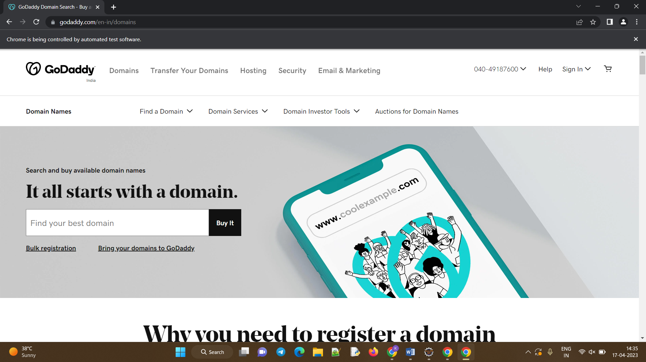

**4)**package DAY7;

import java.util.List;

import org.openqa.selenium.By;

import org.openqa.selenium.WebDriver;

import org.openqa.selenium.WebElement;

import org.openqa.selenium.chrome.ChromeDriver;

import org.openqa.selenium.chrome.ChromeOptions;

import org.testng.annotations.BeforeSuite;

import org.testng.annotations.Test;

import io.github.bonigarcia.wdm.WebDriverManager;

public class NewTest_4 {

WebDriver driver;

@BeforeSuite

void init() {

WebDriverManager.chromedriver().setup();

ChromeOptions co = new ChromeOptions();

co.addArguments("--remote-allow-origins=*");

driver=new ChromeDriver(co);

}

@Test

void Test1() throws InterruptedException

{

String url=("https://opensource-demo.orangehrmlive.com/web/index.php/auth/login");

driver.get(url);

Thread.sleep(3000);

WebElement user=driver.findElement(By.name("username"));

user.sendKeys("Admin");

WebElement password=driver.findElement(By.name("password"));

password.sendKeys("admin123");

WebElement con = driver.findElement(By.xpath("//*[@class=\"oxd-button oxd-button--medium oxd-button--main orangehrm-login-button\"]"));

con.submit();

}

@Test(dependsOnMethods="Test1")

void Test2() throws InterruptedException

{

String end="https://opensource-demo.orangehrmlive.com/web/index.php/dashboard/index";

driver.get(end);

Thread.sleep(4000);

WebElement ds=driver.findElement(By.xpath("//*[@id=\"app\"]/div[1]/div[1]/header/div[1]/div[2]/ul/li/span"));

ds.click();

List<WebElement> menu=driver.findElements(By.xpath("//*[@id=\"app\"]/div[1]/div[1]/header/div[1]/div[2]/ul/li/ul"));

menu.get(3).click();

}

}

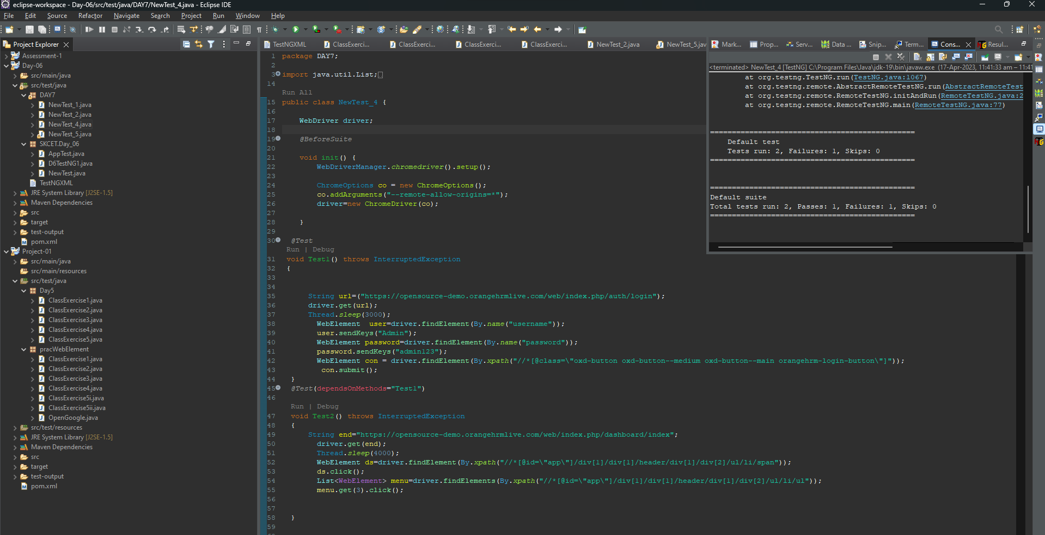

**OUTPUT:**

**5)**

package DAY7;

import java.util.concurrent.TimeUnit;

import org.openqa.selenium.By;

import org.openqa.selenium.WebDriver;

import org.openqa.selenium.chrome.ChromeDriver;

import org.openqa.selenium.chrome.ChromeOptions;

import org.testng.Assert;

import org.testng.annotations.Test;

import io.github.bonigarcia.wdm.WebDriverManager;

public class NewTest_5 {

@Test(groups= {"SmokeTest"})

public void Test1() {

WebDriverManager.chromedriver().setup();

WebDriver driver;

ChromeOptions co = new ChromeOptions();

co.addArguments("--remote-allow-origins=*");

driver=new ChromeDriver(co);

driver.get("https://www.godaddy.com/en-in");

driver.manage().window().maximize();

String actualTitle="Domain Names, Websites, Hosting & Online Marketing Tools - GoDaddy IN";

String extractedTitle=driver.getTitle();

Assert.assertEquals(actualTitle, extractedTitle);

String actualURL="https://www.godaddy.com/en-in";

String extractedURL=driver.getCurrentUrl();

Assert.assertEquals(actualURL, extractedURL);

driver.quit();

driver.manage().timeouts().implicitlyWait(0, TimeUnit.MILLISECONDS);

}

@Test(groups= {"RegressionTest"})

public void Test2() {

WebDriverManager.chromedriver().setup();

WebDriver driver;

ChromeOptions co = new ChromeOptions();

co.addArguments("--remote-allow-origins=*");

driver=new ChromeDriver(co);

driver.get("https://www.godaddy.com/en-in");

driver.manage().window().maximize();

driver.manage().timeouts().implicitlyWait(3000, TimeUnit.SECONDS);

driver.findElement(By.xpath("//*[@id=\"id-631b049a-e9c0-4d24-8710-c504745206dd\"]/div[2]/div[1]/ul/li[1]/button")).click();

driver.findElement(By.linkText("Domain Name Search")).click();

//driver.quit();

}

@Test(groups= {"RegressionTest"})

public void Test3() {

WebDriverManager.chromedriver().setup();

WebDriver driver;

ChromeOptions co = new ChromeOptions();

co.addArguments("--remote-allow-origins=*");

driver=new ChromeDriver(co);

driver.get("https://www.godaddy.com/en-in");

driver.manage().window().maximize();

driver.manage().timeouts().implicitlyWait(3000, TimeUnit.SECONDS);

driver.findElement(By.xpath("//*[@id=\"id-631b049a-e9c0-4d24-8710-c504745206dd\"]/div[2]/div[1]/ul/li[1]/button")).click();

driver.findElement(By.linkText("Domain Name Search")).click();

String titl=driver.getTitle();

System.out.println("Title="+titl);

//driver.quit();

}

}

**OUTPUT:**

